Angular and React – New Project Setup

You can always go back to the completed project to reference while you go along (<http://examples.oreilly.com/0636920045212/)>

1. Install node.js - <https://nodejs.org/en/>. This should install the node package manager (npm) to your machine. Most of the time you will be using the console. Windows users may  a different command prompt that takes you node/npm.
2. Open up terminal/command prompt
3. Install bower from npm, (you already need node, npm (step 1) and git installed)

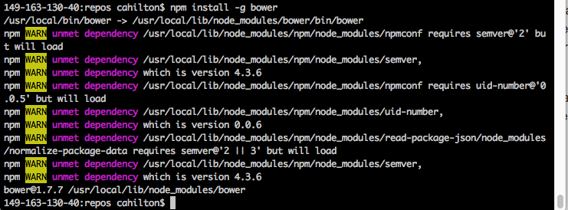

1. Create a directory named 'angular-react-demo’ and go there



1. Initialize npm (you can enter through all the prompts or fill them out)

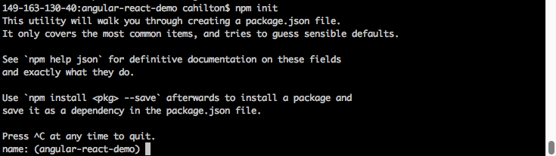

1. Initialize bower (you can enter through the prompts or fill them out)

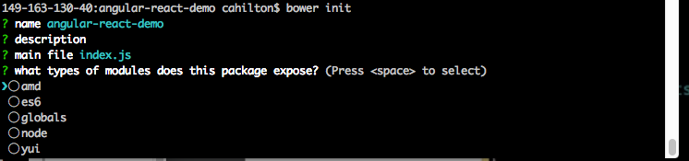

1. Create a git ignore file



1. Add node modules and bower components to git ignore file

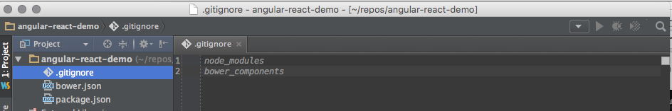

1. Create index.html and main.js in your project (these are blank for now)
2. Install angular from your terminal

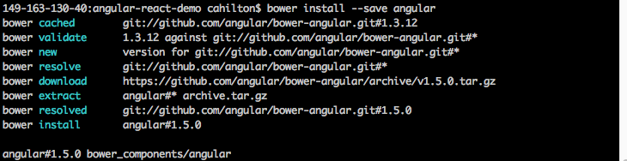

1. Setup your index.html

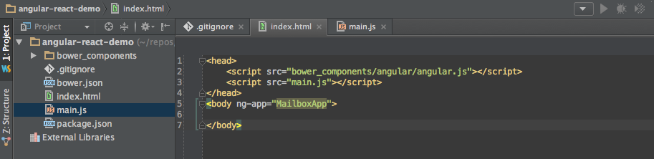

1. Initialize your angular app in main.js

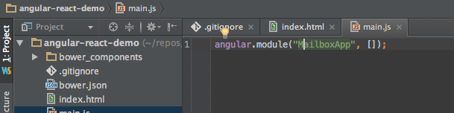

1. Install the angular router from the terminal

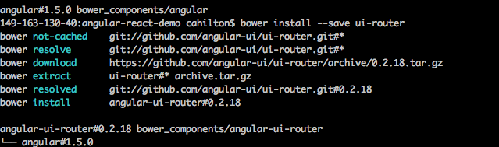

1. Add router as a dependency

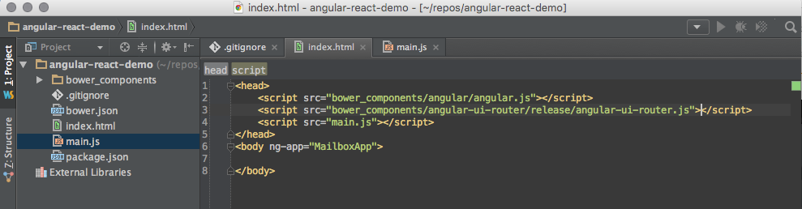

1. Wire your angular url router to your angular app

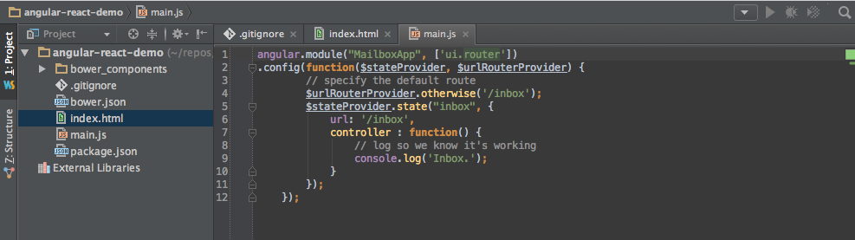

1. Add a ui-view tag to your html (where angular will render your app)

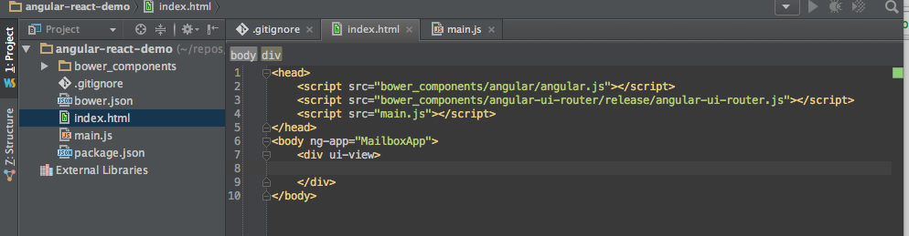

1. Install from your terminal http-server so we can run it

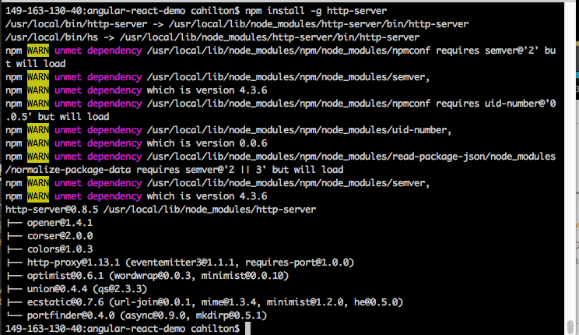

1. Start up http-server from your console

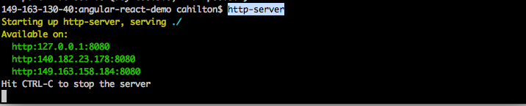

1. Navigate to your browser to the address provided by http-server
2. Open up the developer tools console and verify the log is the same

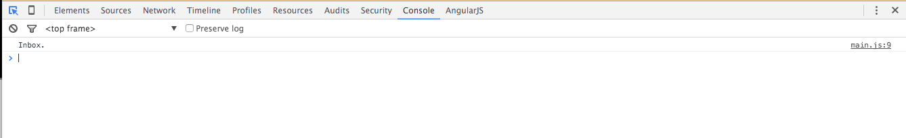

1. Create a ‘partials’ directory, and create inbox.html

<h2>Inbox</h2>  
<div>  
 This is the inbox.  
</div>

1. Add the template url to main.js so the partial will render as the inbox

angular.module("MailboxApp", ['ui.router'])  
.config(**function**($stateProvider, $urlRouterProvider) {  
 // specify the default route  
 $urlRouterProvider.otherwise('/inbox');  
 $stateProvider.state("inbox", {  
 url: '/inbox',  
 templateUrl: 'partials/inbox.html',  
 controller : **function**() {  
 // log so we know it's working  
 console.log('Inbox.');  
 }  
 });  
 });

1. Go to your browser, it should now show the inbox partial



1. Add the $scope variable to your controller, so we can access to modify variables, and bind them to the view

angular.module("MailboxApp", ['ui.router'])  
.config(**function**($stateProvider, $urlRouterProvider) {  
 // specify the default route  
 $urlRouterProvider.otherwise('/inbox');  
 $stateProvider.state("inbox", {  
 url: '/inbox',  
 templateUrl: 'partials/inbox.html',  
 controller : **function**($scope) {  
 $scope.messages = [];  
 }  
 });  
 });

1. Now we chain a service to our config so we can start generating some fake messages

angular.module("MailboxApp", ['ui.router'])  
.config(**function**($stateProvider, $urlRouterProvider) {  
 // specify the default route  
 $urlRouterProvider.otherwise('/inbox');  
 $stateProvider.state("inbox", {  
 url: '/inbox',  
 templateUrl: 'partials/inbox.html',  
 controller : **function**($scope) {  
 $scope.messages = [];  
 }  
 });  
 })  
.service("messageStore", **function**() {  
 **var** messages = [];  
 **var** sampleSize = 100;  
 **for** (**var** i = 0; i < sampleSize; i++) {  
 messages.push( {  
 sender: "john.smith" + i + "gmail.com",  
 date: Date.*now*() - i * 2400000000,  
 id: i,  
 subject: "Regarding report #" + i,  
 body: "Hey Dan, Where's report " + i + "?"  
 });  
 }  
  
 **return** {  
 getMessages:**function**() {  
 **return** messages;  
 }  
 }  
});

1. Now we need to display the messages, so we pass them from the service to the controller

controller : **function**($scope, messageStore) {  
 $scope.messages = messageStore.getMessages();  
}

1. Now we modify our inbox HTML so it shows our messages

<h2>Inbox</h2>  
<h3>  
 You have {{messages.length}} unread messages!  
</h3>  
<div ng-repeat="message in messages">  
 message!  
</div>

1. That shows messages from the service are now bound to the controller and view, but we need to modify it some more so the messages display properly

<h2>Inbox</h2>  
<h3>  
 You have {{messages.length}} unread messages!  
</h3>  
<table>  
 <thead>  
 <th>Sender</th>  
 <th>Subject</th>  
 <th>Date</th>  
 </thead>  
 <tr ng-repeat="message in messages">  
 <td>  
 {{message.sender}}  
 </td>  
 <td>  
 {{message.subject}}  
 </td>  
 <td>  
 {{message.date | date}}  
 </td>  
 </tr>  
</table>

1. Now your app should display the messages:



1. Create a new file in partials/, called message.html, with the following text so you can ‘view’ the messages

<div>  
 <a ui-sref="inbox">Back to the inbox!</a>  
 <table>  
 <tr>  
 <th>From</th>  
 <td>  
 {{message.sender}}  
 </td>  
 </tr>  
 <tr>  
 <th>Subject</th>  
 <td>  
 {{message.subject}}  
 </td>  
 </tr>  
  
 </table>  
 <div>  
 <p>  
 {{message.body}}  
 </p>  
 </div>  
</div>

1. Now we wire up the router and controller in main.js so that individual messages can show.

angular.module("MailboxApp", ['ui.router'])  
.config(**function**($stateProvider, $urlRouterProvider) {  
 // specify the default route  
 $urlRouterProvider.otherwise('/inbox');  
 $stateProvider.state("inbox", {  
 url: '/inbox',  
 templateUrl: 'partials/inbox.html',  
 controller : **function**($scope, messageStore) {  
 $scope.messages = messageStore.getMessages();  
 }  
 }).state('message', {  
 url: '/message/:id',  
 templateUrl: 'partials/message.html',  
 controller: **function**($scope, messageStore, $stateParams) {  
 $scope.message = messageStore.getMessages()  
 .filter(**function**(message) {  
 **return** message.id == $stateParams.id;  
 })[0];  
 }  
 });  
 })

1. Now you should have a simple ‘inbox’ with links that connect the inbox to the clicked message





1. Now we look how we can perform application speed improvement, by using React, so now we go back to our terminal to install some npm packages (gulp, browserify, babelify, vinyl-source-stream)



1. If you haven’t installed gulp before make sure to install it globally.



1. I also had to install this to get it to transpile



1. Rename main.js to main.jsx so we can write JSX in our javascript
2. Now create your gulpfile.js (for gulp, which will serve as our build system for jsx). Note: I had to add presets for babel so it would transpile correctly

**var** gulp = require('gulp');  
**var** source = require('vinyl-source-stream');  
**var** babelify = require('babelify');  
**var** browserify = require('browserify');  
  
gulp.task('jsx', **function**() {  
 **return** browserify(  
 {  
 entries: './main.jsx'  
 }  
 )  
 .transform("babelify", {presets: ["es2015", "react"]})  
 .bundle()  
 .pipe(source('main.js'))  
 .pipe(gulp.dest('./'));  
});

1. Now run gulp, which should compile main.jsx to main.js



1. Now add we’ll start to add JSX to our main class controller
2. controller : **function**($scope, messageStore) {  
    **var** MessageList = React.createClass({  
    render:**function**(){  
    **return** (  
    <div>  
    <h2>  
    {**this**.props.messages.length} Unread Messages  
    </h2>  
    <table>  
     
    <thead>  
    <th>  
    Sender  
    </th>  
    <th>  
     
    Subject  
     
    </th>  
    <th>  
    Date  
    </th>  
    </thead>  
     
    {**this**.props.messages.map(**function**(m,i){  
    **return** (  
    <tr key={i}>  
    <td>  
    {m.sender}  
    </td>  
    <td>  
    <a href={"/#/message/"+i}>  
    {m.subject}  
    </a>  
    </td>  
    <td>  
    {$filter('date')(m.date)}  
    </td>  
    </tr>  
     
    );  
    })}  
    </table>  
    </div>  
    )  
    }  
    });  
   }
3. Make sure to install React



1. Include React in index.html

<head>  
 <script src="bower_components/angular/angular.js"></script>  
 <script src="bower_components/react/react.js"></script>  
 <script src="bower_components/angular-ui-router/release/angular-ui-router.js"></script>  
 <script src="main.js"></script>  
</head>

1. We can now remote the ‘templateUrl’ prop from our inbox state provider, since it’s now managed by React and not Angular
2. So that React can render our messages, add the following after the React createClass call

**var** messages = messageStore.getMessages();  
React.render(<MessageList messages={messages} />, $element[0]);

1. Also, don’t forget to pass in $element and $filter to your controller

controller : **function**($scope, messageStore, $element, $filter) {

1. Now you can transpile jsx again (gulp jsx) and should have the app back to the state it was in, but using React + Angular!
2. Let’s add some style



1. Now include your new css

<link rel="stylesheet" href="bower_components/skeleton/css/skeleton.css">

1. Refresh your page, and it should have much nicer style now. (Note, I added more messages just to try out React)



Note:

I got this error following his instructions, which is why I had to install additional things (steps #35 and #37)

